**Generalize Behavior With Inheritance**

*a class provides a specific implementation of a more general case*

*extract a superclass which separates generic from the specific behavior*

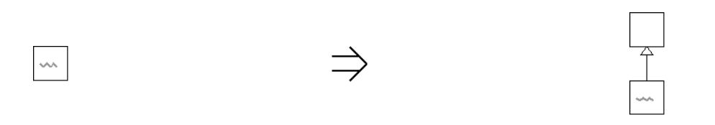

**Context:**  
[Generalize Behavior With Inheritance](https://web.archive.org/web/20090914101008/http:/www.refactoring.be/thumbnails/rtn-gbwi.html) is one of the routes to follow when a variation of an existing abstraction needs to be introduced. Somewhat strange about this refactoring is that it is triggered by variation rather than duplication. An alternative route to follow when inserting a new variation is to [Introduce Duplication](https://web.archive.org/web/20090914101008/http:/www.refactoring.be/thumbnails/rtn-id.html) by copy-paste-modifing the existing code and factor out the duplication afterwards by [Eliminate Duplication By Inheritance](https://web.archive.org/web/20090914101008/http:/www.refactoring.be/thumbnails/rtn-edbi.html).